**JNCIA**

1. **Course Introduction**

The Introduction to Junos Platform Automation and DevOps (IJAUT) course demonstrates how to automate the Junos OS using DevOps automation tools, protocols, and technologies. This course provides an introduction to basic DevOps principles, Junos APIs, and the Network Configuration Protocol (NETCONF). It focuses on using Python, Junos PyEZ, Ansible, and the Junos Representational State Transfer (REST) API to automate Junos platforms. Extensible Markup Language (XML), JavaScript Object Notation (JSON), and YAML Ain't Markup Language (YAML) are introduced as data formats that facilitate Junos automation.

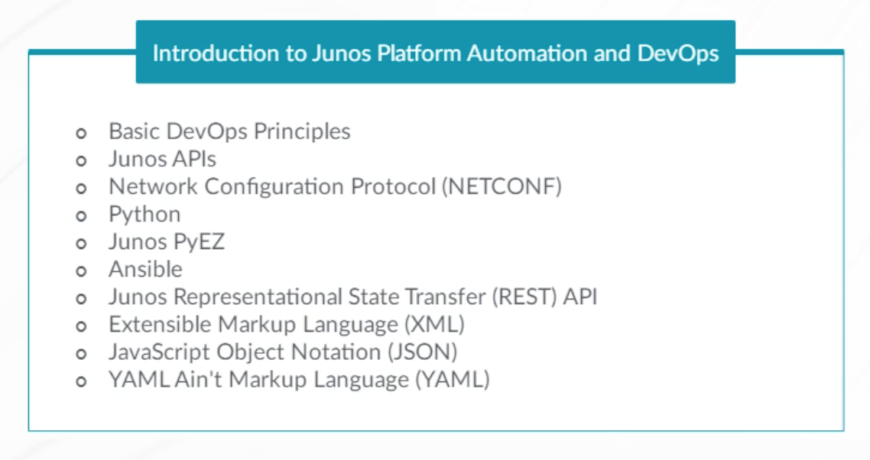

This course benefits individuals responsible for configuring and monitoring devices running the Junos OS.

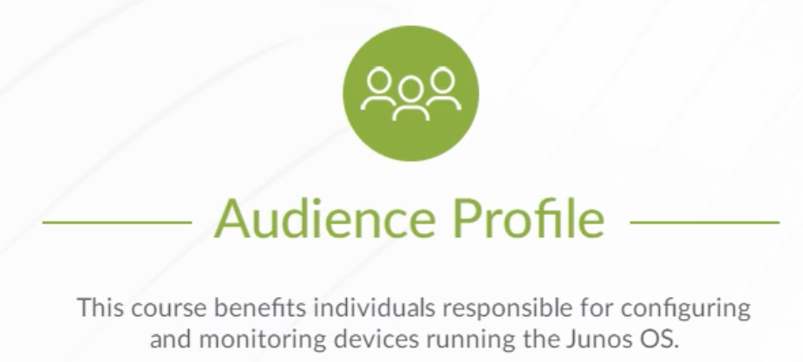

IJAUT is an introductory-level course.



You should have a basic understanding of the OSI model, the TCP/IP protocol suite, and computer networking concepts.

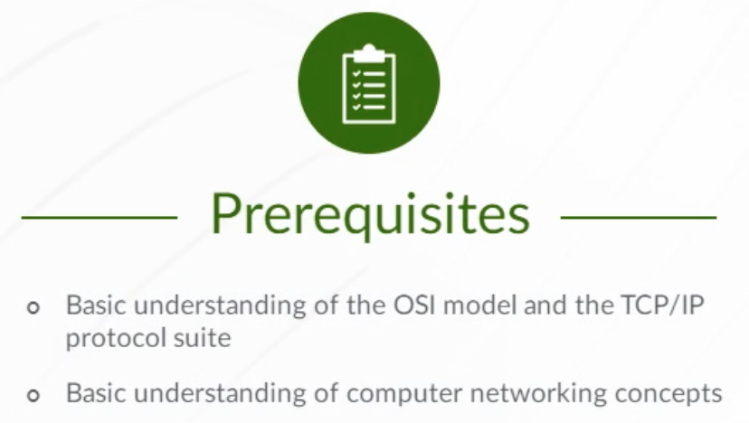

1. **Introduction to DevOps**

**Network Operations**

Traditional computer networks were designed and operated as a set of individual components and services. This traditional structure was used, regardless of whether the networking domain was a service provider WAN or an enterprise data center.

Using a traditional approach to network operations, new customer services are implemented using manual processes, often using a device-level CLI. Implementing new types of network services requires installation of new equipment and connections.

Many of today’s networks lack the flexibility and scalability required to run modern applications. This means network operations becomes a bottleneck as new applications and services are brought online, and the network grows larger and more complex. Traditional network operations also rely on manual failure remediation processes that increase service downtime and negatively impact the customer experience.

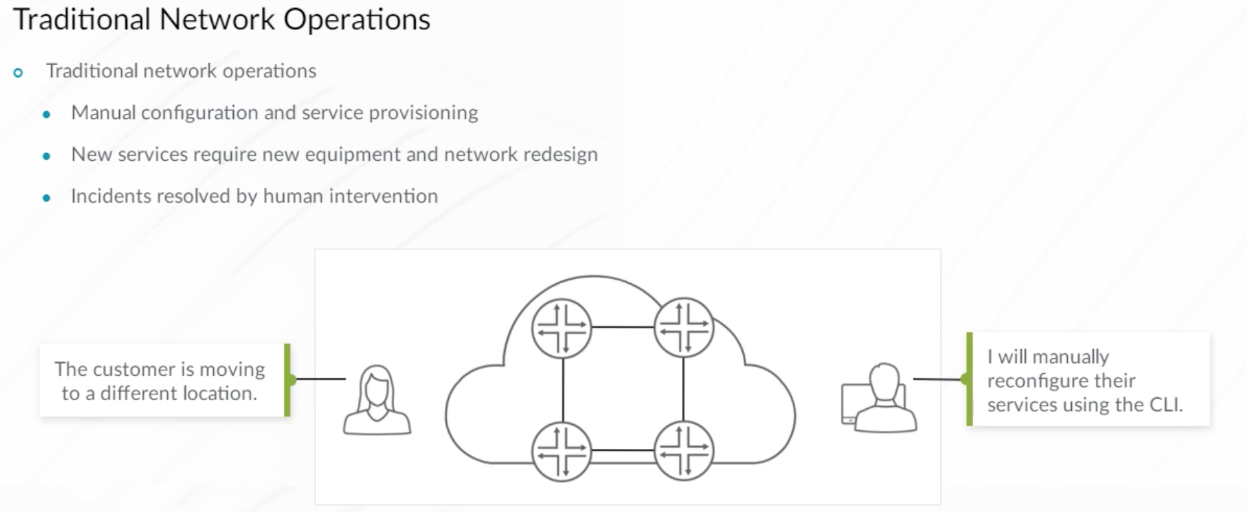

Changes to the way modern applications run, require the network to keep pace. To deploy applications at scale, network and service configuration must be automated. Applications running in virtualized environments, such as private, public, and hybrid clouds, require networking to be virtualized as well. Instead of deploying and managing physical hardware devices, software-based virtual switches, routers, and firewalls are used. Modern networks are also able to dynamically adjust and optimize traffic flow based on the analysis of network telemetry data.

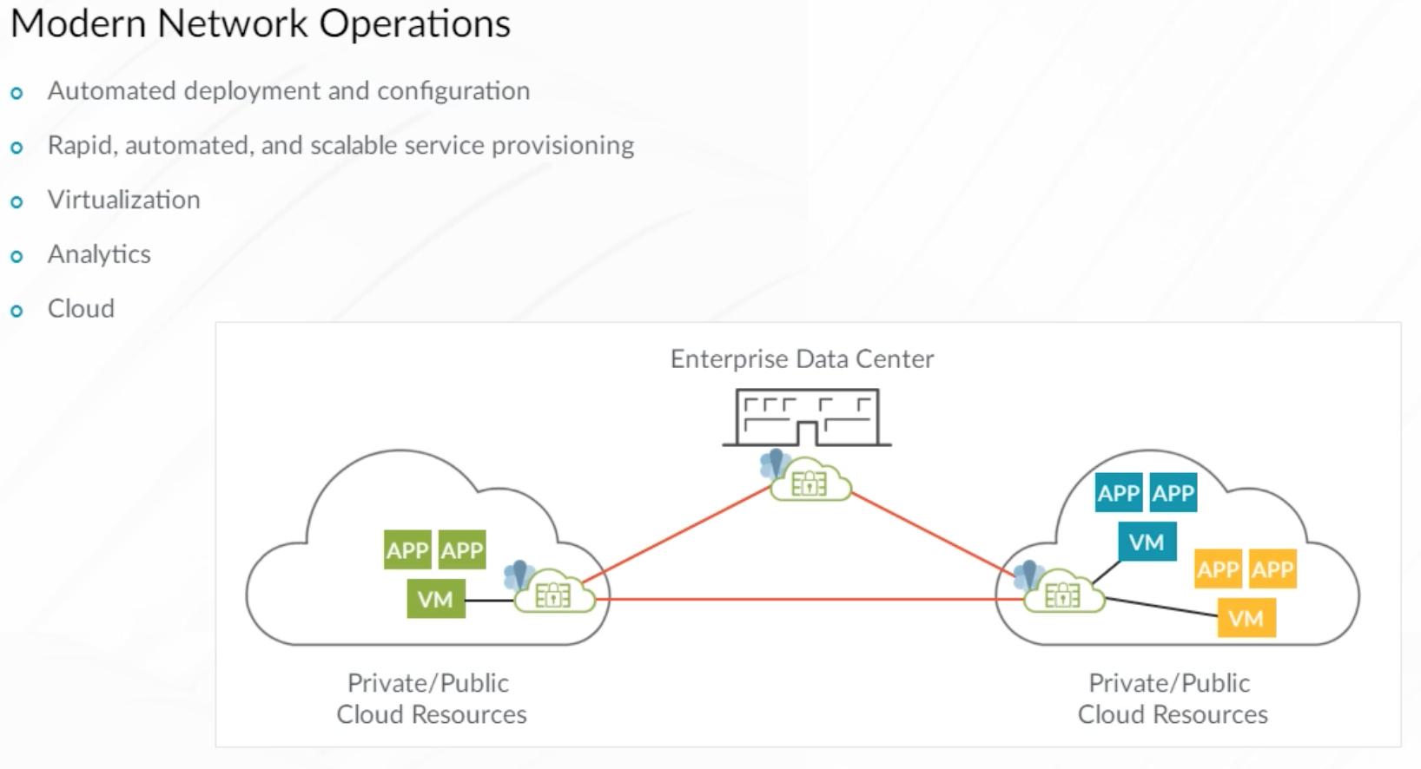

The primary reason for changing the traditional approach to networking comes from the fact that computer networks often exist as parts of larger projects, and must evolve in unison. Consider these examples:

* An application running in a public cloud, where large pools of compute, storage, and networking resources are being shared by many customers (or tenants).
* Scaled Web services accessed by millions of users requiring multiple tiers of a Web application to be dynamically connected.
* A traditional telecom operator choosing to evolve their business model and become a content delivery operator. The network must be adapted to deliver different, ever-changing content (for example, video, data, gaming, and so on) to millions of subscribers.
* In environments like public clouds, networking may be completely virtualized and run in software.

Because of these trends, networking is now being treated more like a software project, with corresponding characteristics like version control, code reviews, test before deploy, and so on.

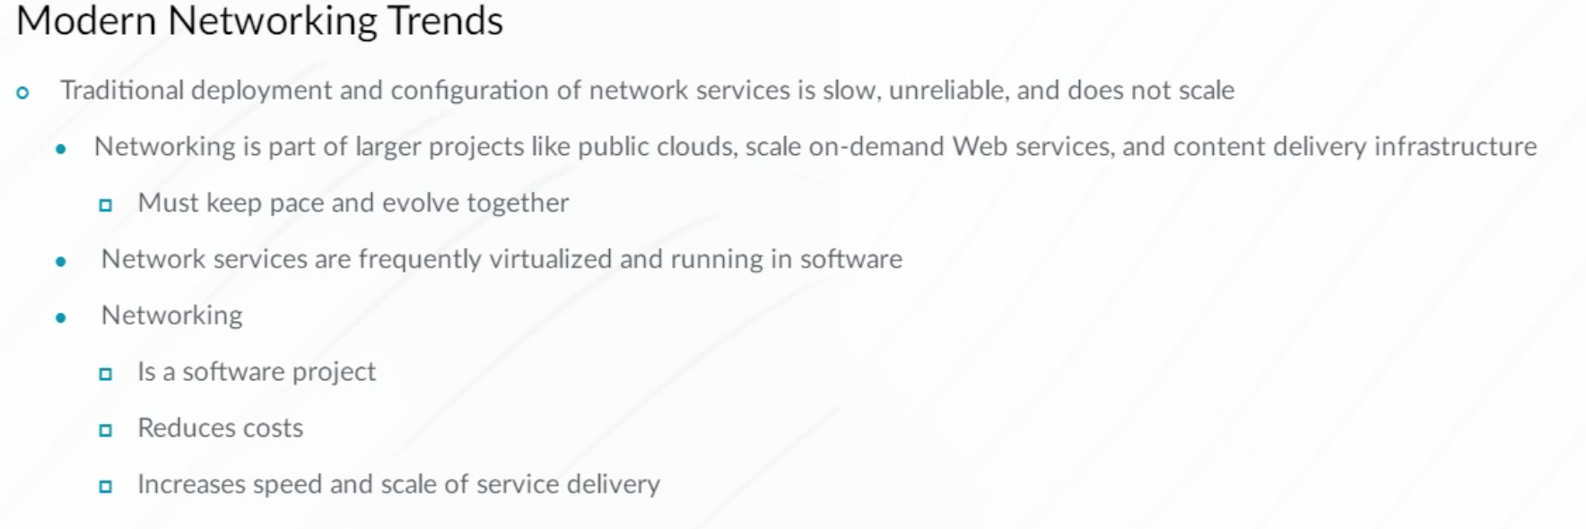

Because networks are now being treated like software, you will learn about some software development methodologies. The classical approach to software development is summarized by what is called the waterfall model. Its formal description was first given by W. Royce in 1970, while the actual term ‘waterfall’ was introduced by T.E. Bell and T.A. Thayer in 1976.

Based on this software development model, you first collect requirements for the new software before the software design process begins. After the design process is complete, then the design is implemented in code. Finally, you can test and deploy the new software. Each phase of the development process begins only after finishing the previous one.

The waterfall model works if you know your requirements very well in the beginning of the development process. When requirements change during the development process, and a need to develop new functionality arises, the waterfall model shows some weakness. It is not the most flexible development model, and requires more time before new application functionality can be deployed to production.

Additionally, the waterfall model takes into account there is a significant interval of time between releases of software. Each new release contains a large volume of code changes because multiple features are typically released at the same time. This increases the probability of issues at the deployment time.

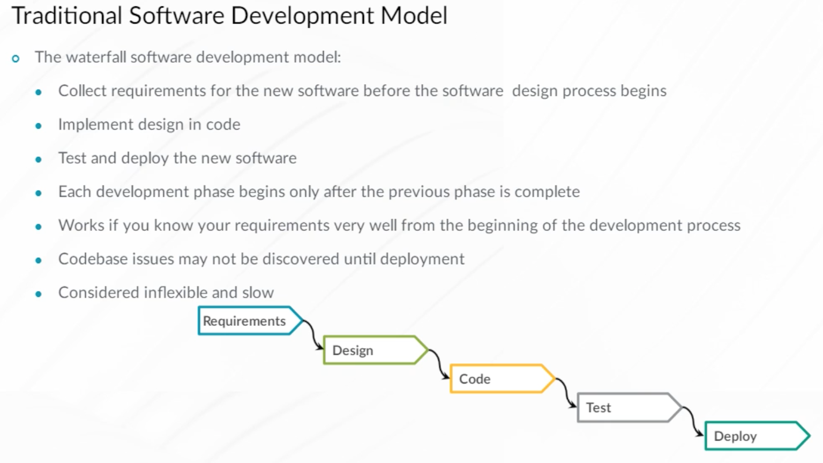

Agile is an umbrella term for multiple software development practices that began appearing in the past few decades. These practices permit a much more iterative and incremental development process compared to the classical waterfall model and its variants.

In 2001, leading software developers came together to create the ‘Manifesto for Agile Software Development’, stating these 12 main principles:

* The highest priority is customer satisfaction through early and continuous delivery of software.
* Welcome changing requirements, even late in development. Agile processes harness change for the customer’s competitive advantage.
* Frequently deliver working software in time frames ranging from a couple of weeks to a couple of months, with a preference to the shorter timescale.
* Business people and developers work together daily throughout the project.
* Build projects around motivated individuals. Give them the environment and support that they need, and trust them to get the job done.
* The most efficient and effective method of conveying information to and within a development team is face-to- face conversation.
* Working software is the primary measure of progress.
* Agile processes promote sustainable development. Sponsors, developers, and users should be able to maintain a constant pace indefinitely.
* Continuous attention to technical excellence and good design enhances agility.
* Simplicity by maximizing the amount of work not done is essential.
* The best architectures, requirements, and designs emerge from self-organizing teams.
* At regular intervals, the team reflects on how to become more effective, then adjusts its behavior accordingly.

The Manifesto for Agile software development is available at the **Agile Manifesto**website. You can access the website from the Reference Links document.

The Agile Software Manifesto formulated the main values of Agile such as:

* Individuals and interactions over processes and tools,
* Working software over comprehensive documentation,
* Customer collaboration over contract negotiation, and
* Responding to change over following a plan.

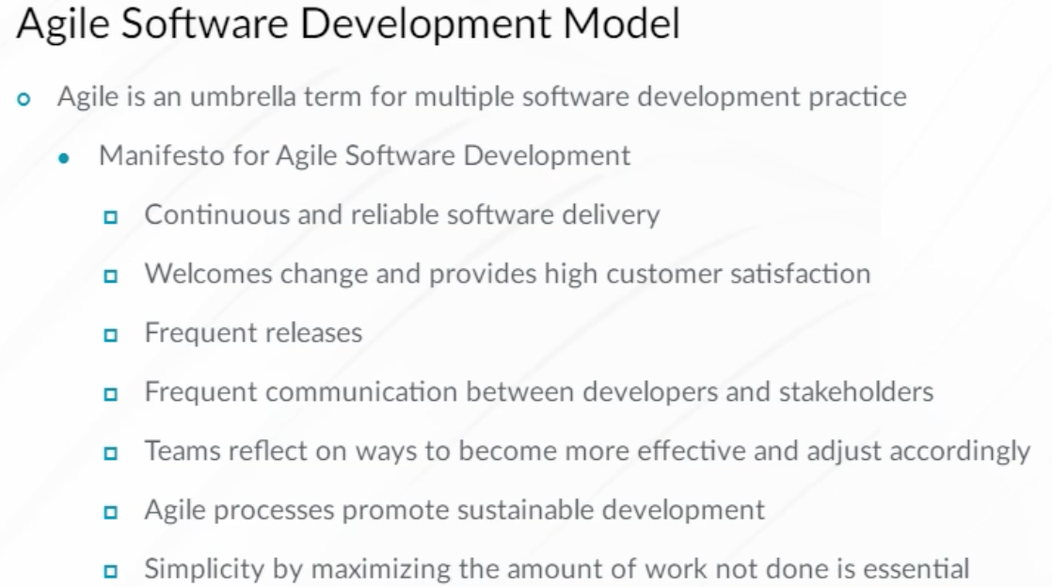

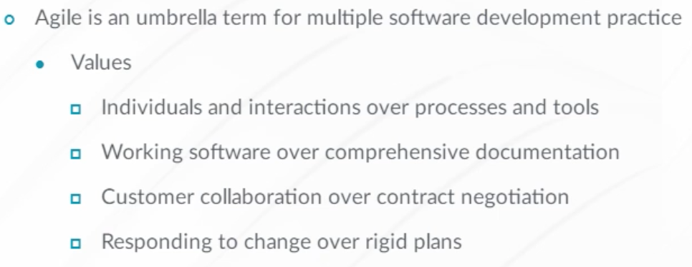

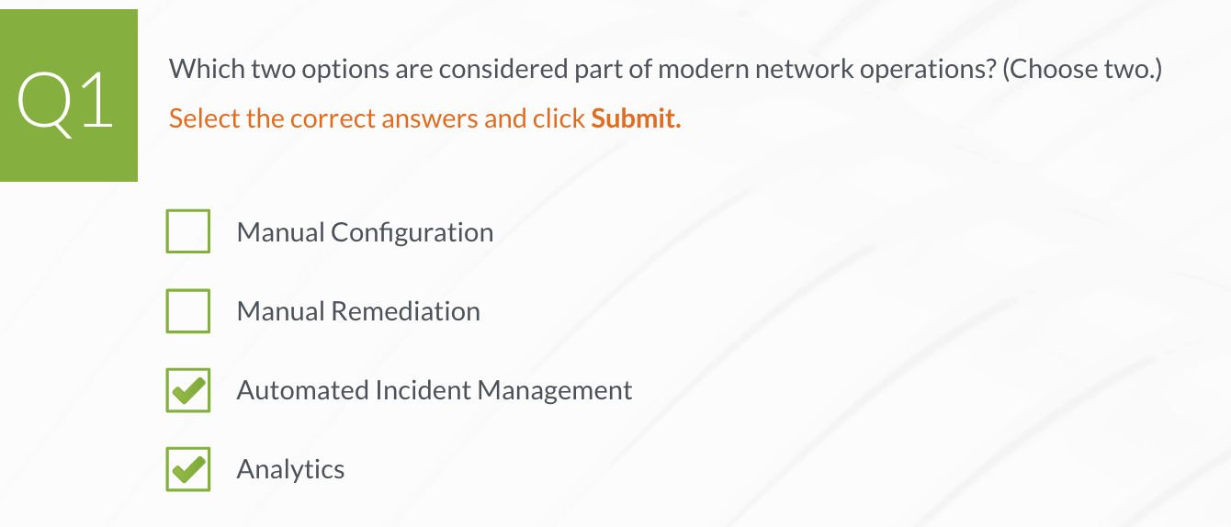

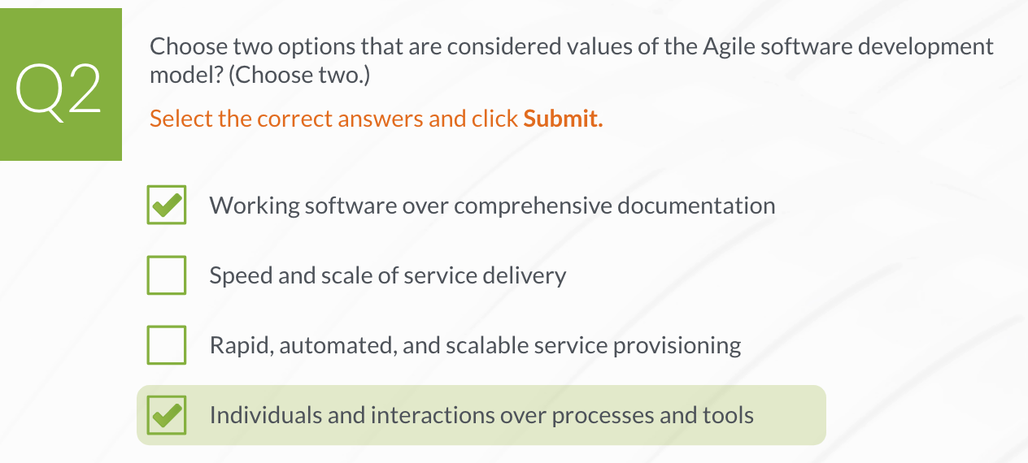

**DevOps Principles**

DevOps is a combination of technologies, design concepts, mentalities, and ideals that enable high-performing IT teams to move quickly while maintaining stability.

DevOps aims to unite development, operations, and other teams in your organization to improve communication, collaboration, and integration. DevOps creates a tight loop between product release and feedback, with the ultimate goal of decreasing the time to market while increasing organizational performance and customer satisfaction.

DevOps philosophies originated within the software engineering culture, as well as within the lean manufacturing revolution that began during the 1980s. The main principle of lean manufacturing is eliminating everything in the production chain that does not help to create the final product.

Using DevOps, changes in functionality can happen frequently, and are moved to production quickly. Automation and orchestration play a critical role, and if errors are encountered, a system can be quickly rolled back to a known state.

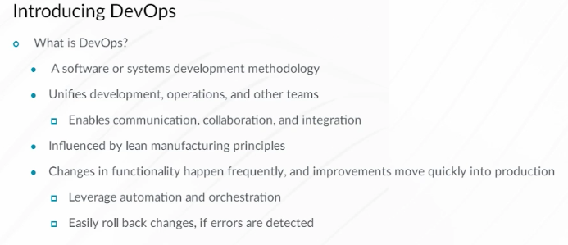

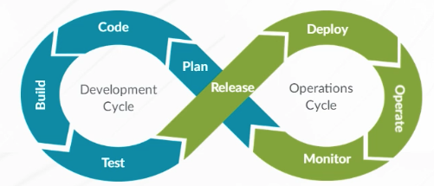

DevOps enables quicker integration of new software, especially software upgrades and patches. It enables developers to deliver software in smaller portions using a faster cadence. The overall result of adapting DevOps practices is faster time to market for new functionality, and an overall increase in organizational performance, product quality, and security. The DevOps practice of maintaining identical development, testing, staging, and production environments creates confidence that the new software will deploy successfully.

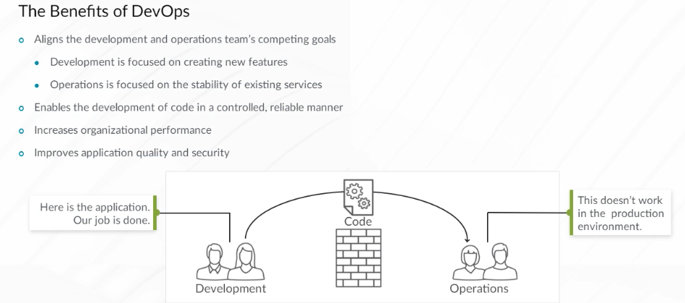

Traditionally, networks have been managed on a device-by-device basis. Deploying simple changes, such as adding VLANs to ports in medium to large networks, causes considerable strain on network operations. At the same time, compute infrastructure operators have adopted DevOps tools and processes that enable them to move quickly.

DevOps aims to align technology, design, and processes. While software development teams and compute infrastructure teams have embraced these methodologies, network operations is just starting to come on board. Junos automation solutions enable network engineers and operators to move at the rapid pace demanded by the DevOps community. Juniper embraces various automation and orchestration tools such as Ansible, Puppet, Chef, Salt, and so on. Junos enables network engineers to use common DevOps tools for full orchestration of large-scale service deployments.

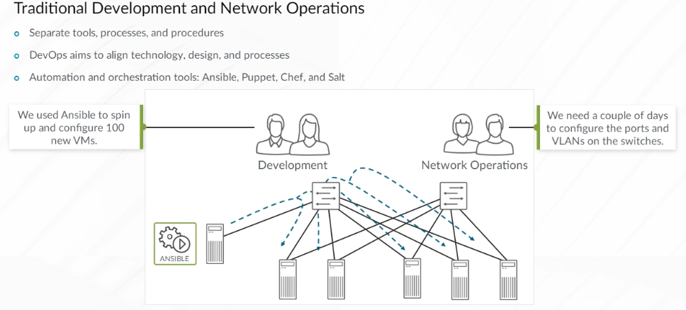

DevOps brings automation to the network resulting in increased speed, reduced cost, and a decrease in the number of configuration errors. Junos devices are completely programmable. Every capability baked into the Junos CLI is exposed to developers, making the platforms completely automatable.

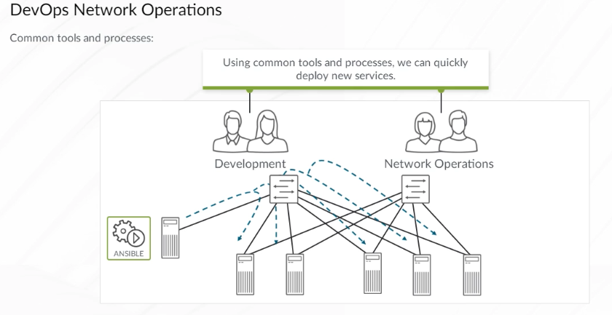

As you investigate automating your network, you might encounter the term Infrastructure as Code (IaC). This term is used both, inside and outside of DevOps circles. IaC is a very popular method to manage cloud-based resources because it provides complete infrastructure life cycle management. All infrastructure is managed and provisioned using code. This generally includes deploying new virtual servers, applications, and networking, and also terminating those resources when they are no longer needed.

Using code, you can create a new virtual router, switch, firewall, or any other virtualized network function (VNF). You can then configure and monitor the virtual device using code, just as you would a physical device. Virtual devices are also easy to move and duplicate when needed. This makes it possible for your development, test, staging, and production environments to be identical. Juniper’s vMX, cSRX, and vSRX are examples of virtual network devices.

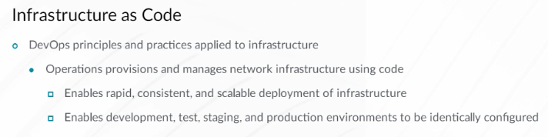

A typical IaC workflow is shown here. Code is created and then stored in a version control system (VCS). Next, the device code goes through an automated code review process, is integrated back into the primary code branch, and is deployed. You can see how closely the IaC project workflow resembles the workflow of a typical application development project. Management of your infrastructure is now a coding project.

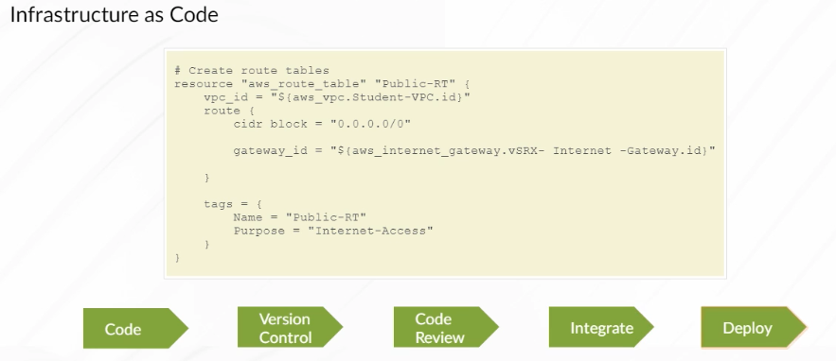

The practices of DevOps are an outcome of its culture. Adopting the practices without the culture, creates a short-lived experiment too shallow to stick. Understanding and internalizing the DevOps ‘Three Ways’ principles help you develop a DevOps mindset.

The DevOps ‘Three Ways’ are basic principles which all DevOps practices naturally follow. They are:

* Flow,
* Feedback, and
* Continuous experimentation and learning.

Work flows from developers to operations. Feedback is returned to the development team, and adjustments are made. Continual experimentation and learning is a frequent, reoccurring process.

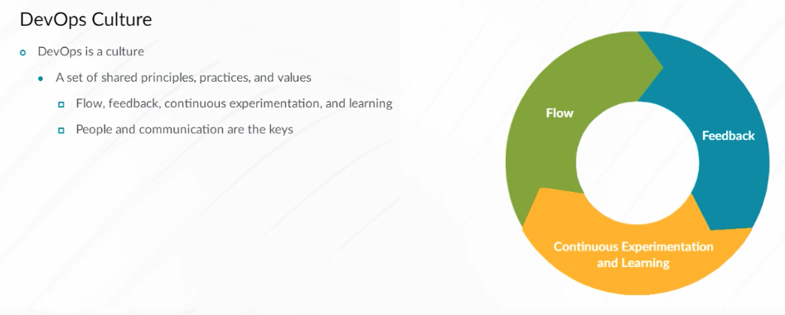

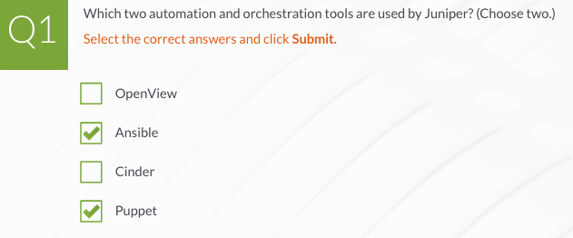

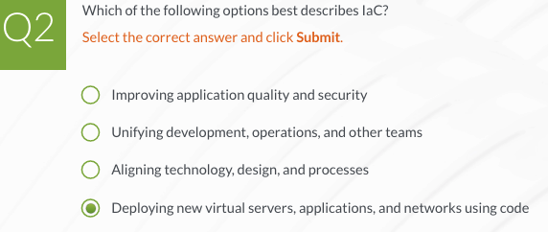

**DevOps Practices**

With any production system, there is a process flow from beginning to end. In manufacturing, the process flow begins when an order is placed and ends once the product is delivered to the customer. In an application development environment, the flow begins when a new software product, feature, or change is requested, and ends when the software, feature, or change is delivered to the customer. The goal in both manufacturing and software development is to shorten the time to deliver.

One of the first things an organization can do to improve process flow is to stop doing things that are going to hurt those downstream in the production process. All participants need to understand the production flow and how what they do affects others in the organization later on. Common problems include poor documentation, sloppy code, or implementing new features without sharing that information with others in development and IT.

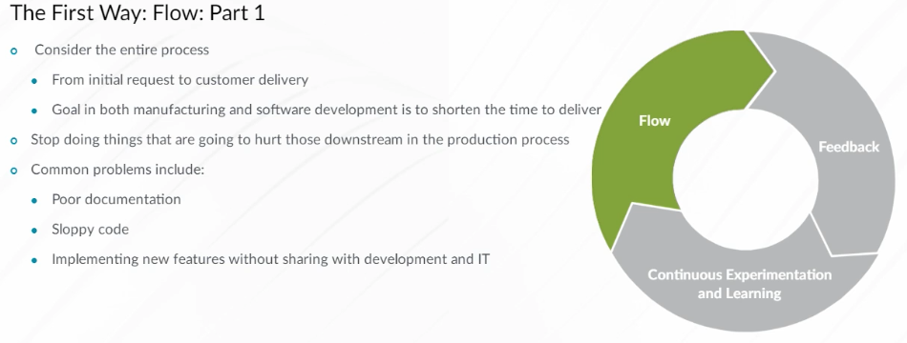

Sometimes, a local improvement in the code or in IT operations may improve the function of an individual code module or network function but degrade the system as a whole. Always keep the health of the entire system in mind when working on an individual part. If you have two options for doing the same task, focus on the one that increases the rate of flow in the long run. For example, it may take more time to implement automation than it takes to do the task manually. However, if you automate a repetitive task, the value of that automation far outweighs the value of getting the task done quickly one time.

Technical debt is something that occurs when you implement a short-term work-around to get a product out the door. You know that you should circle back to repair the work-around later. However, because you didn’t have time to do the task right the first time, it is unlikely that you will have time to revisit the work-around in the future and clean it up. Soon, you’ll find that you must create a new work-around to maneuver past old work-arounds. Like financial debt, technical debt also accumulates interest as time marches on.

Eventually, the house of cards comes crashing down and the pile of broken quick-fixes becomes the source of much pain. Make sure that you give enough time to implement the proper solution initially, so that you don’t enter into technical debt. Provide developers and IT operations teams the necessary time to avoid or clean up technical debt as an anticipated part of their workload.

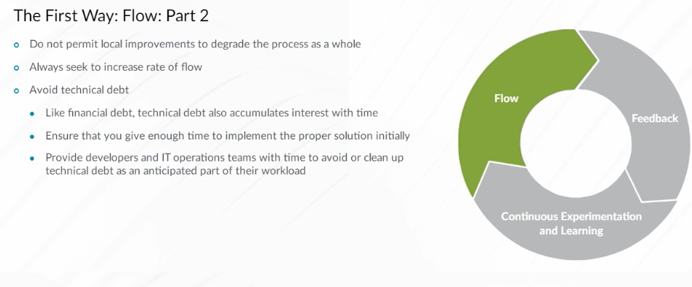

The second way is feedback—continuously gather feedback from each stage in the flow process. You utilize this feedback to know what is working, what is not, and what needs to improve. Collect feedback from developers, operations, customers, and anyone else who may have information that can help you improve the flow or quality of the product. You can collect feedback from people, as well as from automated monitoring and measuring systems. Feedback is a primary method for identifying ways to shorten and improve the flow.

Using feedback to shorten your process flow includes shortening the time it takes to collect and analyze feedback. Note that the sooner you get feedback, the sooner you can integrate positive changes into the system.

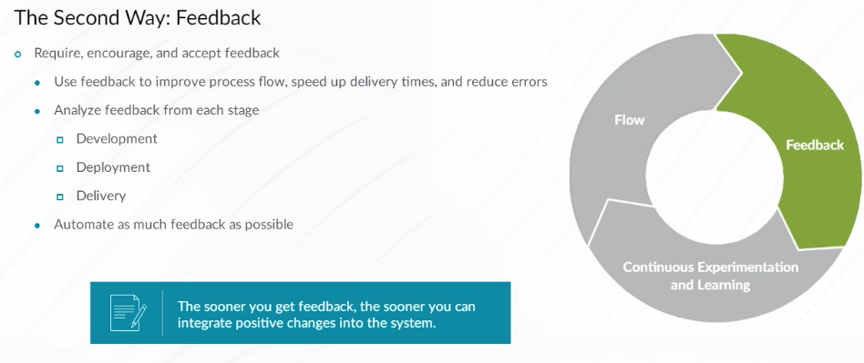

Set aside time to evaluate feedback and implement improvements. Feedback, process speed, and product quality metrics should be gathered over time to determine if a flow is improving. It is also important to give time in an employee’s workload to implement improvements. Some companies give up to 20 percent of a worker’s time to implement improvements. If everyone understands that the ultimate goal is to improve the flow, participants are unafraid to suggest improvements in their own processes that could improve the system as a whole. They begin to feel confident enough to take risks and try new things that can improve the flow even further. Individuals who are willing to take the risk of innovation should be rewarded for their efforts.

As much as you strive to make a system fault-tolerant, it is difficult to know just how tolerant a system is to failure until you test it. Finding and eliminating risk in a system is much easier when you are actively searching for points of failure as part of a plan to improve. Some companies purposely unplug devices or break processes temporarily to stress-test a system and observe how employees and systems deal with the problem. Testing a system helps to ensure that theoretical recovery plans work when it counts.

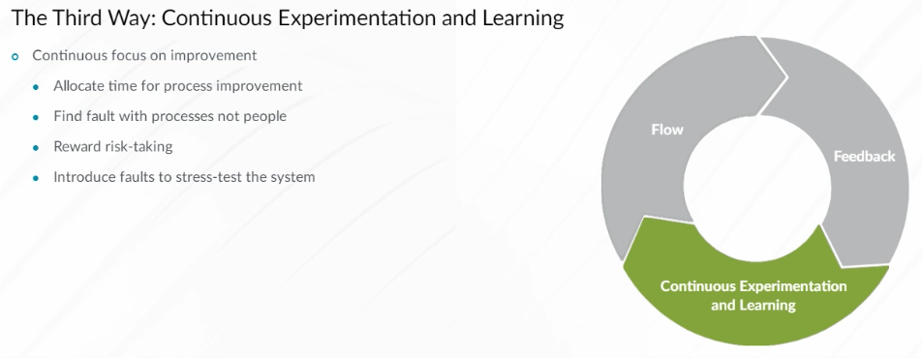

Continuous Integration (CI) is the practice of frequently committing the code to a shared central repository and automating the build and test process of the code each time someone pushes new code into the repository. The goal of CI is to provide rapid feedback. If a defect is introduced into the code base, it should be identified and corrected as soon as possible. For CI to work, a VCS, such as Git, is used. Some additional tools that automatically perform tests on the code might also be required.

A major aspect of CI is that developers are routinely reintegrating the code with which they are working back into the primary or main branch of code in the VCS. The longer developers wait to integrate their code with the main branch, the more likely it is that there will be incompatibilities that slow the flow of production. Submitting the code for integration at least once a day is recommended.

With continuous building and testing, the primary code is theoretically in a releasable state at any time. Quality, compliance, and security testing are performed at each step of the process. Reserving extra time for testing at the end of the process is unnecessary since testing occurs throughout the process.

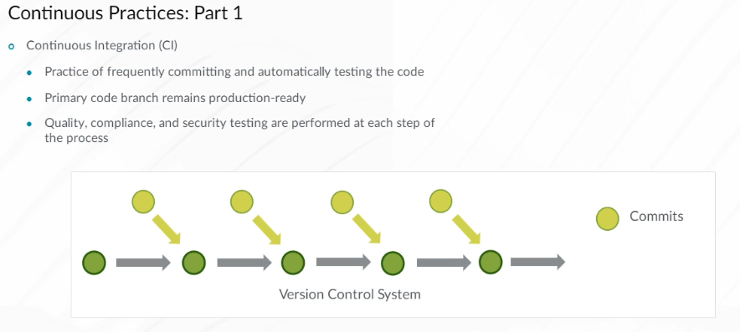

Continuous delivery and continuous Deployment are natural extensions of CI. These terms are often used to describe the DevOps model. The difference between the two is that Continuous Delivery makes sure that the code is ready to deploy at any time, while Continuous Deployment is a way to automate the code deployment. The most important aspect of Continuous Delivery and Continuous Deployment is that operations, security, and compliance teams are brought into the conversation much earlier than before. Being a part of the process early on enables these teams to give valuable input and visualize the process from beginning to end.

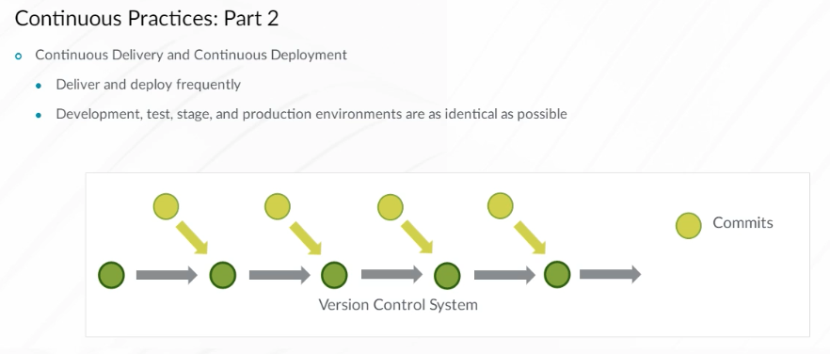

Depending on the size of your organization and the exact field of activity, DevOps principles can be implemented differently.

Google’s Site Reliability Engineering (SRE) started as a software engineer’s way to manage repetitive tasks, and is now an extended set of principles, practices, and incentives, which helps to manage large and complicated services at scale. One can view SRE as a specific implementation of DevOps with some extensions. DevOps can also be thought of as a generalization of several core SRE principles to a wider range of use cases.

Network Reliability Engineering (NRE) can be thought of as a DevOps implementation for networking. It has its own specifics and yet, still uses many of the common DevOps ideas, approaches, and tools.

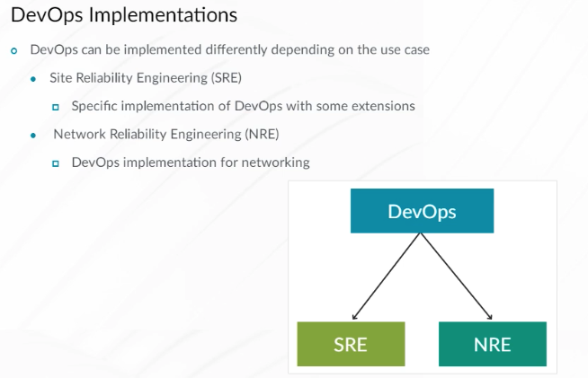

Traditional network operations are a bit like fire fighting, with fire disguised as randomly appearing network failures that require manual intervention to resolve. NREs employ DevOps principles to ensure reliable network operations.

It focuses on customer satisfaction and service availability. Networking is inseparable from connected systems and applications. NRE embraces failure as a way to ensure the same error does not happen again, relies on proactive testing, and is a continuous journey.

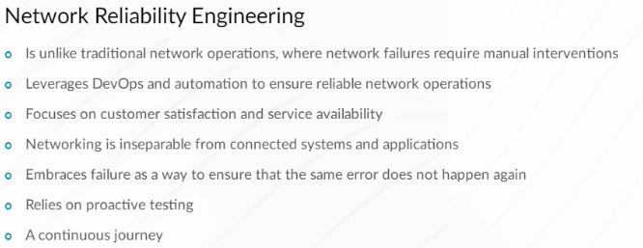

The main NRE behaviors can be summarized as:

* Codify: Beginning with the acquisition of network software and hardware systems (commonly called day 0), an NRE codifies the network software artifacts, secrets, and configuration into source-code repositories similar to a software developer.
* Automate: Using a DevNetOps pipeline, an NRE automates development, testing, staging, and production deployments. NREs use this pipeline to provide reliability, scale, efficiency, and optimization for dynamic provisioning of networking resources for its consumers, and systems integration.
* Test: Through automation, staging, and stress testing, an NRE ensures that the deliveries are reliable enough to meet service-level objectives and agreements.
* Monitor: An NRE monitors service-level indicators, both manually and automatically, and using analytics, triggers automatic responses and alerts for anomalous and statistically meaningful events. Logs and telemetry are collected and analyzed to derive insights used to optimize network performance.
* Measure: The NRE culture values truth and transparency, and uses indicators to measure their effectiveness in meeting reliability goals, such as mean time between failure (MTBF) and mean time to resolution (MTTR).
* Improve: Permanently improve the stability of the system, visibility, and incident reaction time.

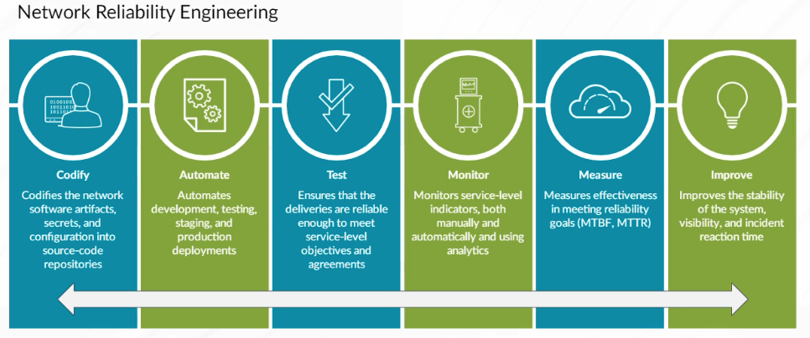

Network DevOps is the application of DevOps philosophies, principles, and behaviors to network operations (NetOps). Network Reliability Engineers put it into practice. DevOps principles counter the waterfall methodology where extended planning, building, and testing cycles occur in long sequential stages. Research has shown that for the IT and manufacturing industries, smaller and more frequent deployments result in improved operational speed, agility, and quality.

By working in shorter and faster cycles with smaller deployment deliverables, a Network DevOps pipeline reduces the time between design changes and production deployment. All network changes go through the same pipeline to ensure consistency.

Although the stages can vary in different implementations, the Network DevOps pipeline stages are common:

* In the design change stage, the network architects and engineers, based on business needs and customer feedback, decide what change is needed in the network
* In the commit change to VCS stage, the change, in the form of code, is committed to a VCS
* In the notify and peer review stage, the team is notified of the proposed change, and team members review and approve or reject the change
* In the automated testing stage, the tests run automatically, ideally in separate testing and staging environments
* In the automated deployment stage, the change is deployed (committed) to production. The team is notified about deployment success or failure. Failed deployments can be rolled back
* In the continuous monitoring stage, the network telemetry is collected and analyzed to provide real-time network performance indicators. The telemetry is compared to service-level indicators, and is used to make reactive or proactive adjustments to the network
* Finally, in the continuous improvement stage, the failure is viewed as an opportunity to improve. Feedback is encouraged, and is used to optimize the overall system performance.

1. **Junos Automation API Overview**

Automation has been a part of Junos since its inception. Over the past 25+ years, the Junos OS has developed rich automation capabilities and supports multiple APIs, libraries, tools, and programming languages. The different layers of the Junos automation stack and the protocols, and languages that the Junos OS supports for automation is provided.

Just above the Routing Engine and the Packet Forwarding Engine layer sits the Junos OS. The Junos OS includes the kernel that provides infrastructure for the Junos processes. These processes carry out the core functions of the Junos OS. When you automate a Junos device, it is these processes that eventually execute the automation commands.

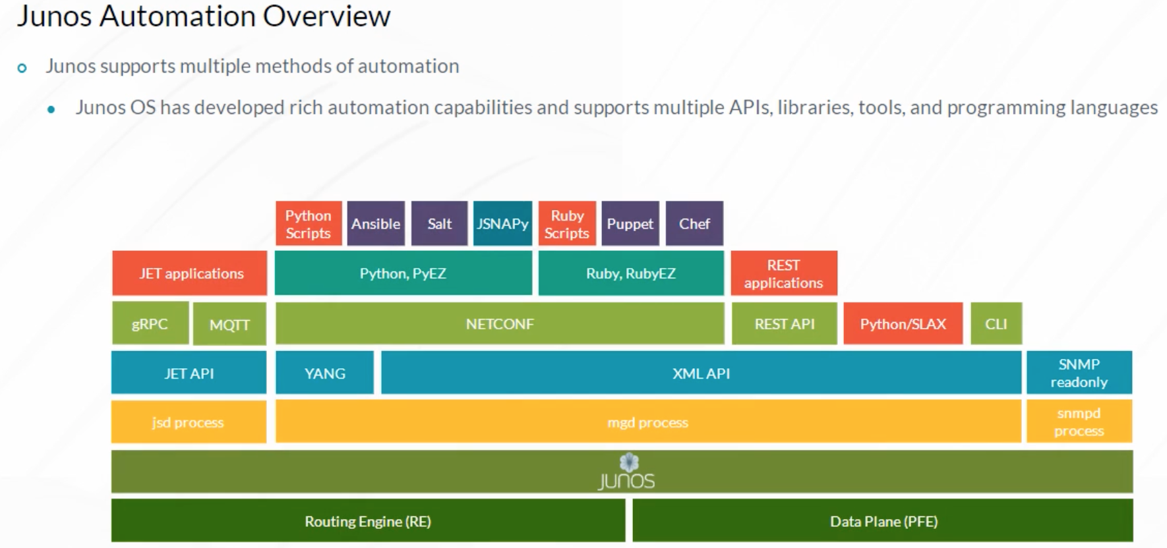

The main Junos processes responsible for automation are the management process (mgd) and the Juniper Extension Toolkit (JET) service process (jsd). The mgd handles automation requests received using the Junos XML, Yet Another Next Generation (YANG), and Representational State Transfer (REST) APIs, as well as some functions. For example, Ansible executes locally stored Python modules and accesses the Junos device using the Network Configuration Protocol (NETCONF) and the XML API. Junos forwards the received Ansible commands to the Junos mgd process for execution. The jsd service handles automation requests that use JET API.

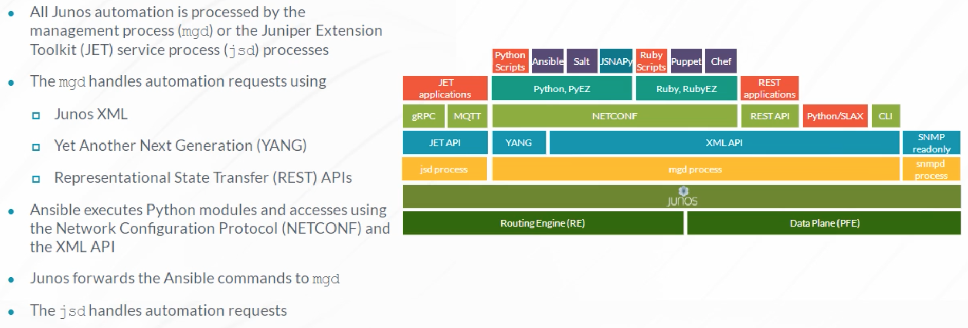

Junos works well in DevOps environments for these reasons:

* Junos has a rich set of APIs.
* Junos uses transactional configuration updates (the Junos commit model).
* Junos configuration and operational data are based on a consistent XML data model.
* Junos supports popular IT automation and configuration management systems such as Ansible, Salt, Puppet, and Chef.
* In addition to remote management through APIs, Junos supports on-box scripts and applications.

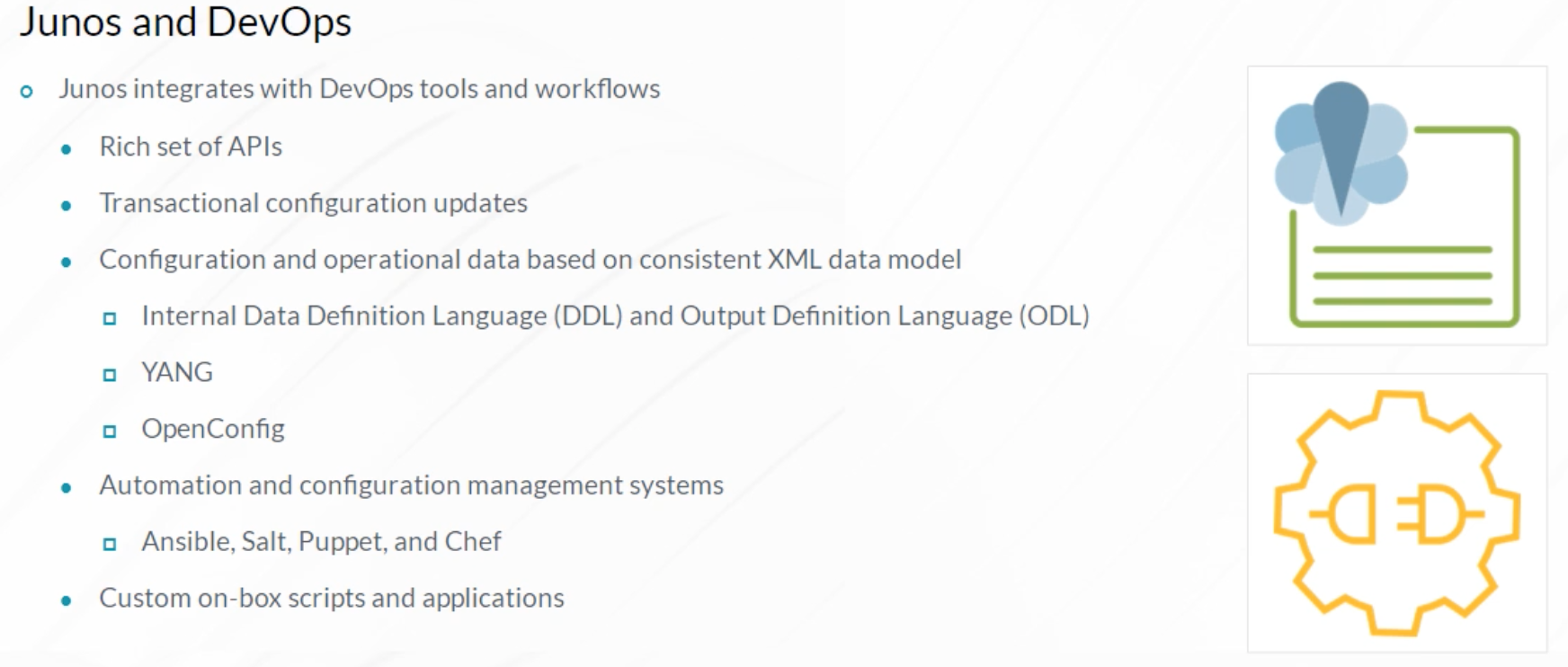

The Junos XML API provides on-box automation (operation, commit, event, and SNMP scripts), as well as off-box automation using third-party automation tools. To retrieve data from the Junos XML API, off-box solutions must leverage a protocol to transmit XML documents. One protocol used for Junos off-box automation is NETCONF.

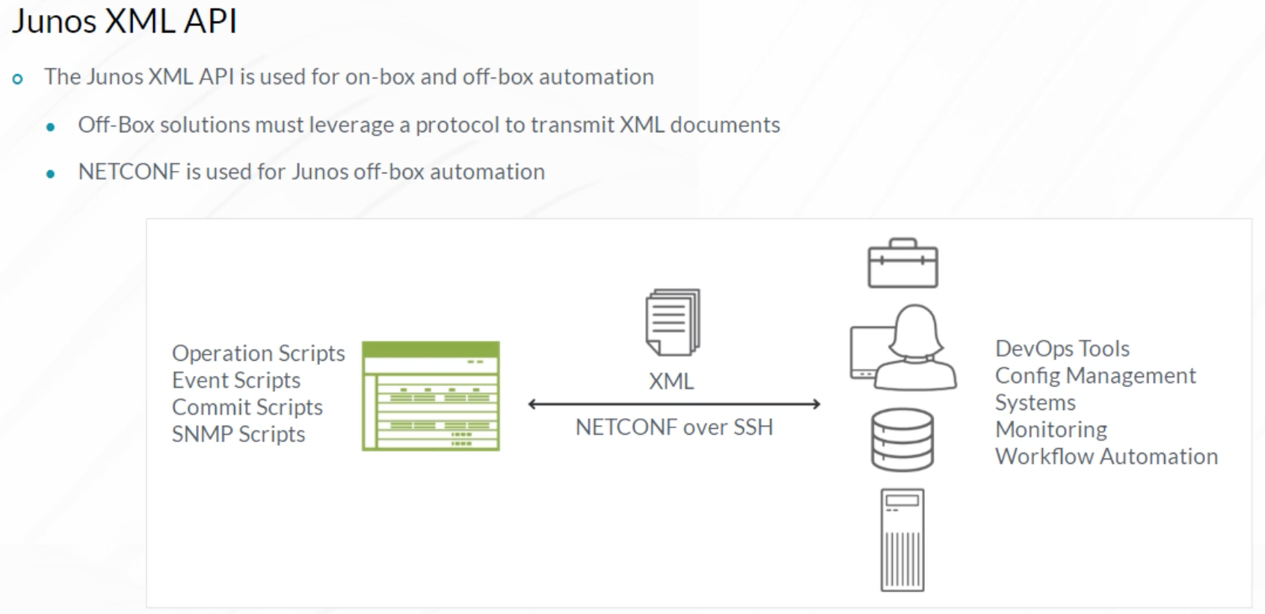

NETCONF is an open, standards-based protocol (RFC 6241), and is used by multiple vendors. NETCONF contains mechanisms that provide full programmatic access to Junos devices. Using XML documents and remote procedure calls (RPCs), you can transport configuration data and operational commands to network devices. NETCONF has been Juniper’s automation protocol of choice for many years, and is supported on all Junos devices.

It is the foundation upon which many Juniper automation technologies are built including, Junos PyEZ, YANG, and OpenConfig. In most cases, NETCONF uses SSH as the transport protocol, although RFC 6241 enables other options (for example, Transport Layer Security (TLS)).

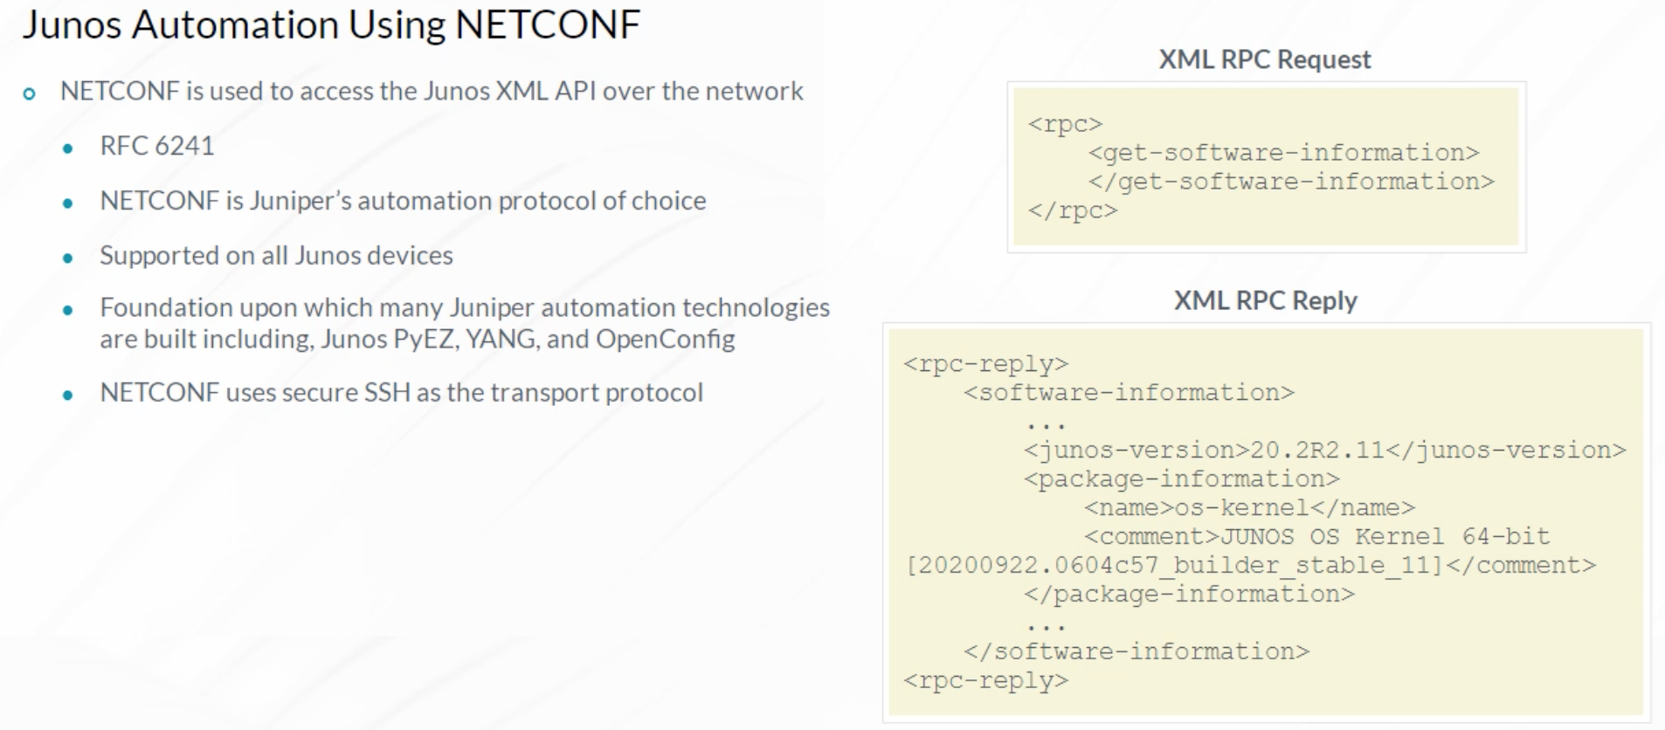

Libraries that make automating your network easier are available for multiple programming languages. These libraries provide simple and flexible options for connecting to Junos devices using NETCONF, and leverage the Junos XML API for management.

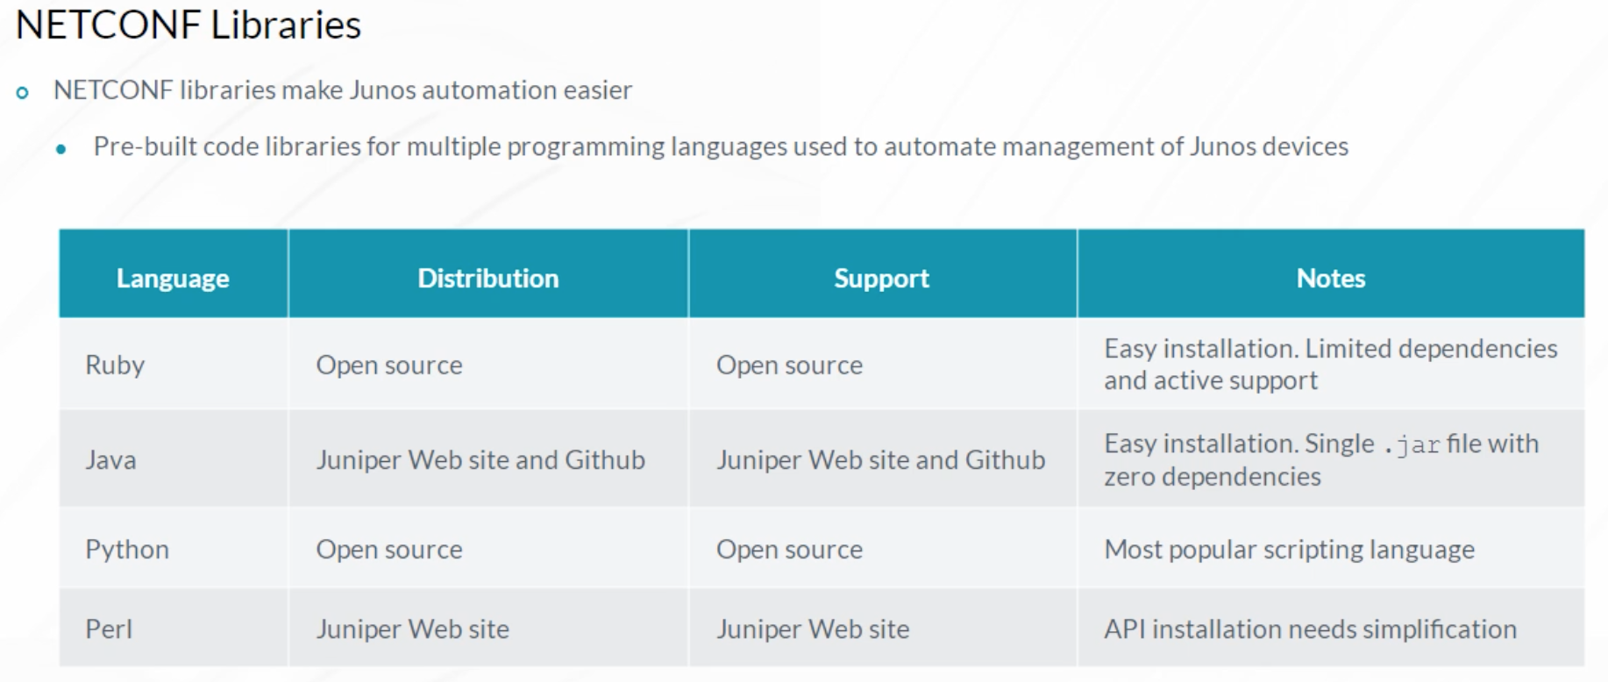

A REST API provides HTTP clients access to objects that correspond to unique URLs on a REST server. REST clients use HTTP methods, like GET, PUT, and POST, and data in the request body to perform actions on the REST server. REST is considered stateless because no client context is stored on the REST server. All session state is maintained on the REST client.

Each request from a REST client contains all the information necessary to process the request. A REST API can be accessed using any program or programming language capable of generating HTTP commands. Tools like Postman or cURL are commonly used for testing. For actual programming, libraries have been developed for many programming languages, like Python, that simplify the generation of REST API requests.

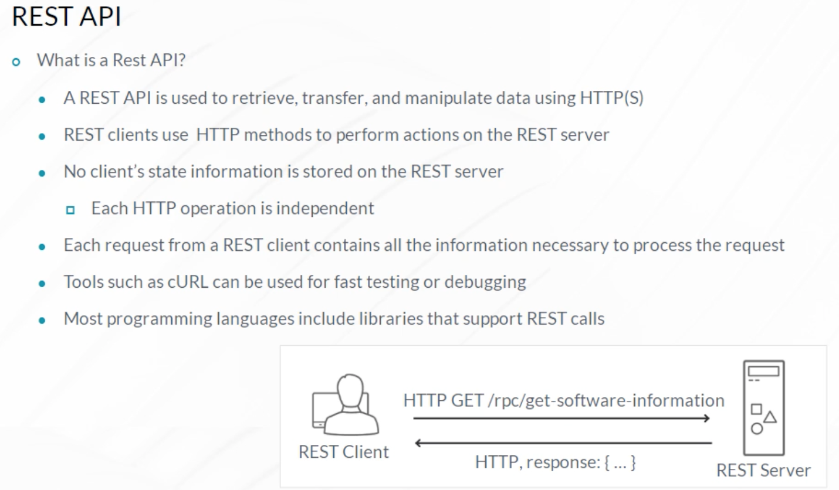

Junos provides a REST API on MX, PTX, QFX, T, and SRX Series platforms including the vMX and vSRX. It exposes Junos configuration and operational mode capabilities to REST HTTP clients.

The example demonstrates using the cURL utility to execute a get-software-information RPC on the 192.168.1.1 host and the XML response. This output is equivalent to a Junos CLI **show version** operational mode command.

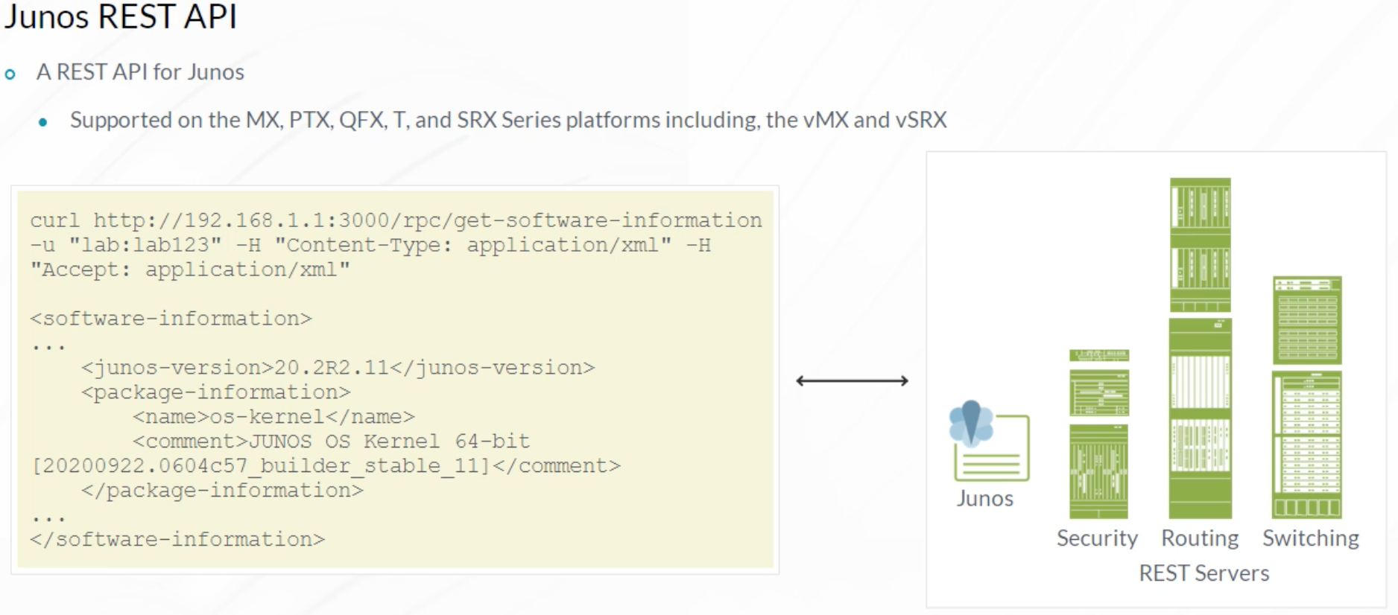

Organizations using management or monitoring systems based on REST can easily integrate Junos platforms. Other benefits of the Junos REST API include ease of configuration, no need to enable or use NETCONF, the ability to retrieve data in multiple formats, the availability of a REST API explorer, and support for Secure Sockets Layer (SSL).

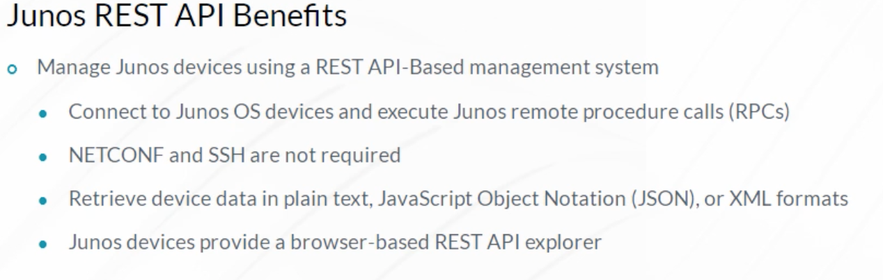

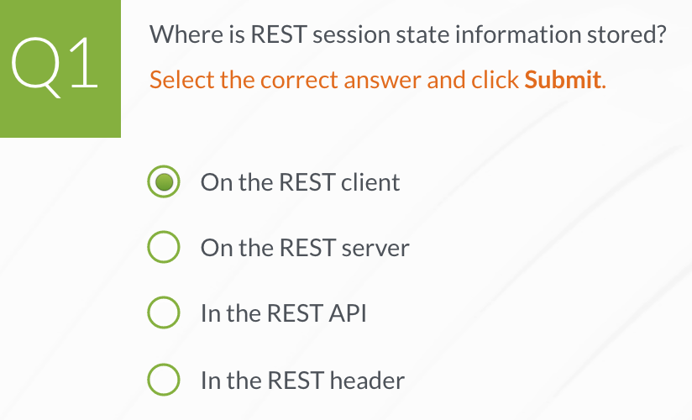

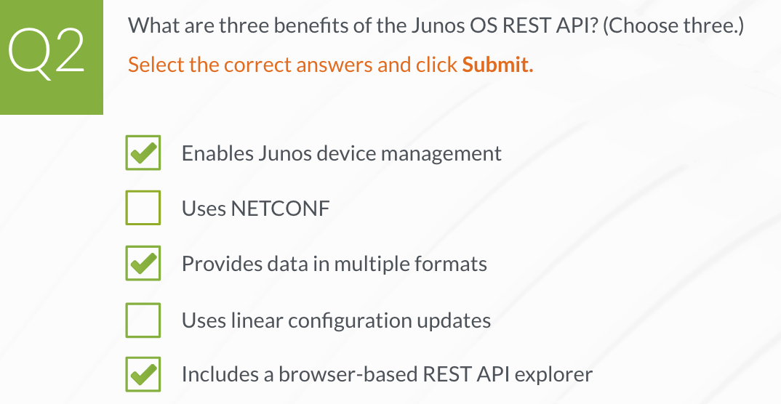

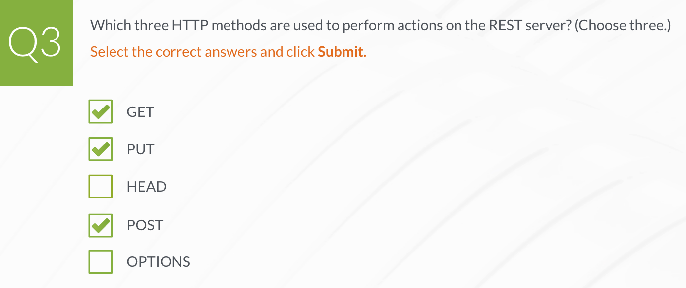

1. **XML and NETCONF**

XML is a standards-based way of structuring and communicating data. It was developed by the World Wide Web Consortium (W3C). Many Junos OS automation tools make extensive use of XML to exchange data. Both the Junos OS CLI and the Junos OS infrastructure communicate using XML.

When an operational mode command is entered in the Junos OS CLI, the CLI converts the command into XML format for processing. After processing the command, the Junos OS returns the output in an XML document, which the CLI converts back into a readable format for display. Remote Junos OS automation applications can use XML-based data encoding to perform operational and configuration operations. The Junos OS XML API provides an XML equivalent for all statements in the Junos OS configuration hierarchy and most operational mode CLI commands. Each operational mode command with a Junos OS XML counterpart maps to a request tag element and, if necessary, a response tag element.

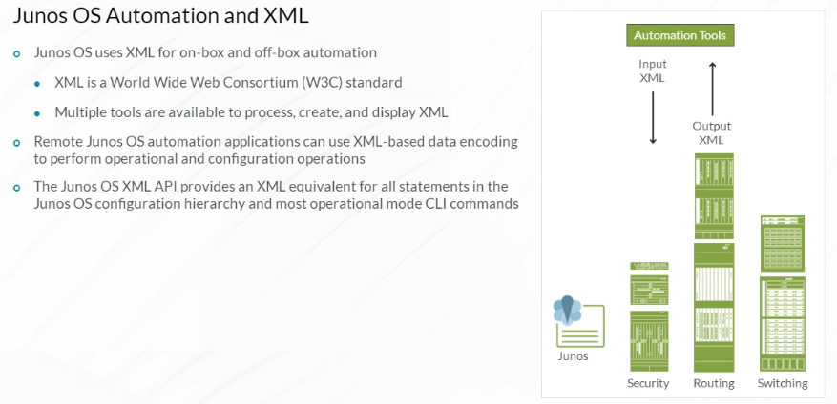

XML is a standards-based way to structure and communicate information. It looks similar to HTML because it uses tags in a similar fashion. XML tags communicate information about the data contained between the tags. XML documents are strictly hierarchical, so opening and closing tags showing the start and end of the data, to which an XML tag applies, must always be present. This is not always true in HTML. XML data representing the course name between opening and closing tags is shown. The XML data is formally identified as a text node, while the full construct including the tags is an element node.

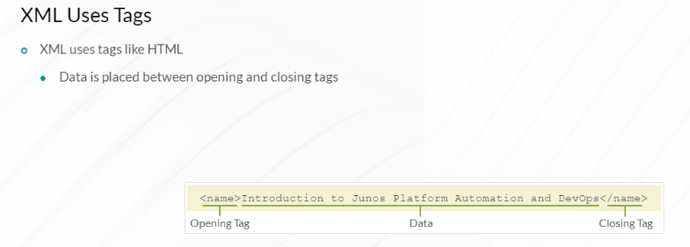

This example shows two methods that are used to represent a level of an XML hierarchy when no data is present. In some cases, there is no data to put between the opening and closing tags for a particular level in an XML hierarchy. In this case, you can combine the opening and closing tags using XML shorthand notation.

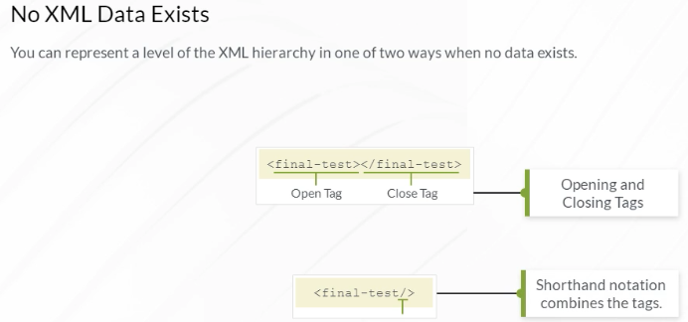

The beginning of an XML document that represents the course name is shown. The root level of the document is an element node named course. All content for the course falls between the opening and closing tags.

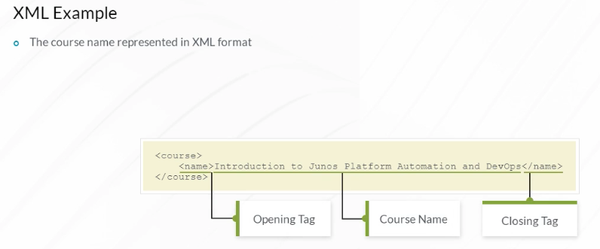

Next, a few new sections are defined in the XML document to organize the course modules.

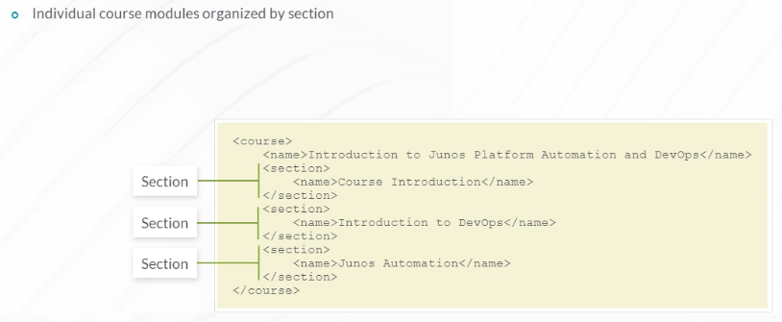

Next, a few subsections are defined. As you can see, using XML, you are able to represent the hierarchical structure of the course. You can add extra information to any of these elements and also, add extra elements.

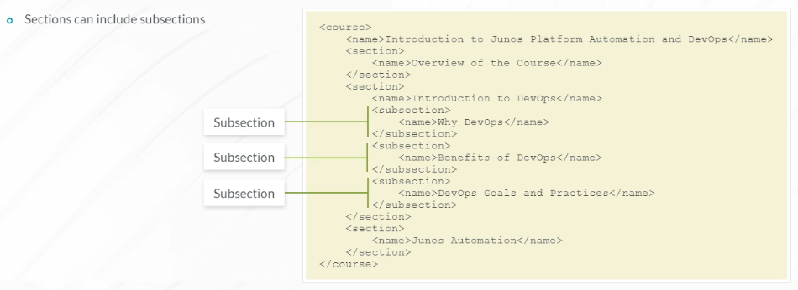

XML namespaces are used to guarantee uniqueness for element names and data values in an XML document. An XML document namespace is defined using the xmlns attribute. Defining a unique document namespace is recommended because XML document data is commonly collected and merged into larger data sets and applications. Each document’s unique namespace greatly reduces the probability of an element name or element value collision when the data is merged. In the example XML document, the <course> element node and all nodes that are within the <course> element node share the same namespace.

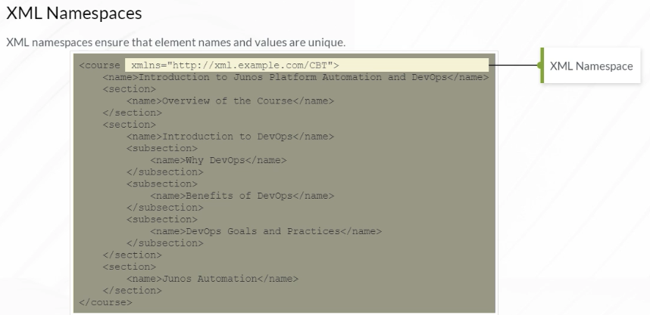

The same XML document can use elements defined using different namespaces. In the example, the main namespace is http://xml.example.com/CBT. But, anything beginning with the graphics: identifier uses a different namespace, defined as http://xml.example.com/GRAPHICS.

Anyone using the XML document can identify which elements use which namespaces.

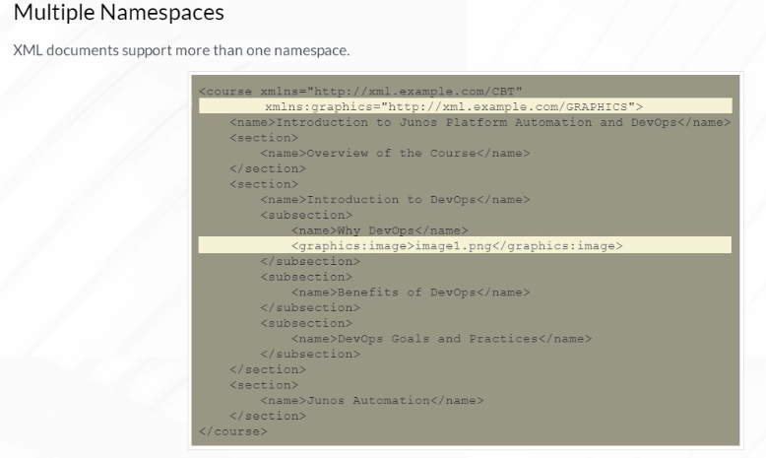

People like the flexibility of XML and use it to represent all types of data using their own unique XML data structures. With this flexibility comes a question–, if any type of data can be organized in an XML hierarchical structure, how do computers or people know how to interpret the XML document? An XML schema definition (XSD) document is a file that ensures that everyone working with an XML document is using a standard set of tags to communicate information. The XSD is what makes the XML document meaningful. XSD, like XML, is a standard developed by W3C. XSD documents are themselves XML documents using a specific structure defined in the W3C standard.

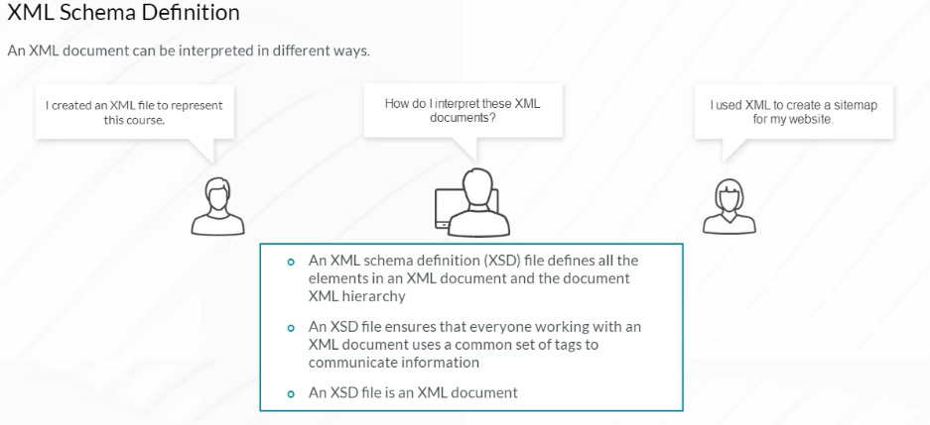

An example of a simple XSD file is shown. You can see how complex XML type rootType is defined, containing a sequence of elements named device-name, interface-count, and date-created. Each element type is defined to be either a string, an integer, or a date. Using the XSD file in the example, a valid XML document matching the XSD file contains a root element named root, with nested elements device-name, interface-count, and date-created. Of course, many other documents that use the same schema definition can also be created.

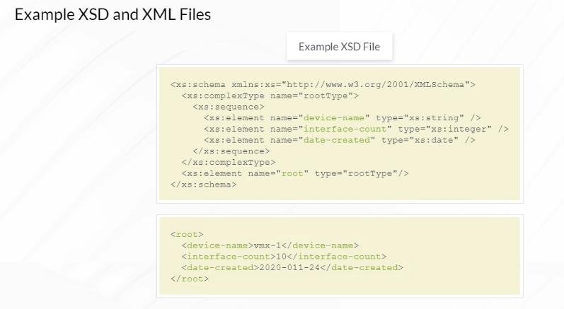

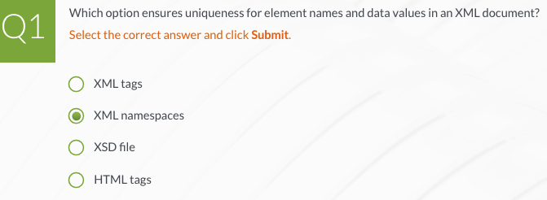

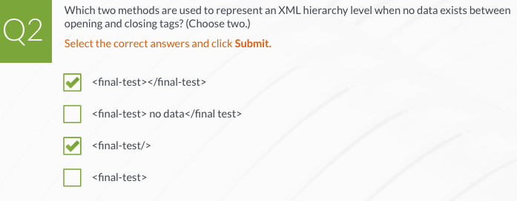

Juniper developed the Junos XML Management Protocol, formerly known as JUNOScript, as an easy, reliable method of automating Junos devices.

After using and improving JUNOScript for several years, Juniper worked with the IETF and shared it with the broader networking community. The solution was renamed as Network Configuration Protocol (NETCONF) and first appeared as RFC 4741. Support for SSH was added in RFC 4742. These RFCs were then updated in 2011 by RFC 6241 and RFC 6242.

The real strength of NETCONF is that it is a management protocol developed specifically for networking devices. NETCONF can lock, read, modify, delete, and unlock a device configuration. It also has the ability to issue operational mode commands. Since NETCONF is an IETF standard, it is used by multiple vendors, enabling organizations to use the same protocol to manage different vendor devices.

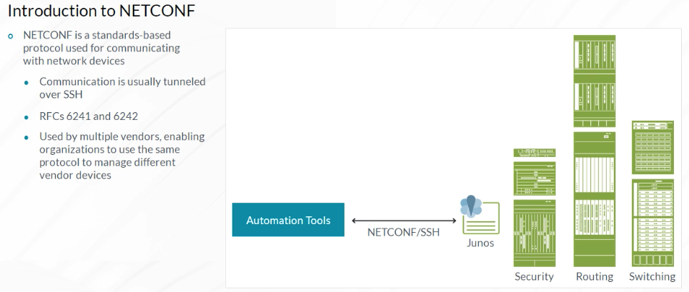

The NETCONF protocol is built specifically for networking and consists of four layers. The Transport layer is responsible for creating sessions with network devices. The sessions can be established using the protocols shown. Junos primarily uses SSH.

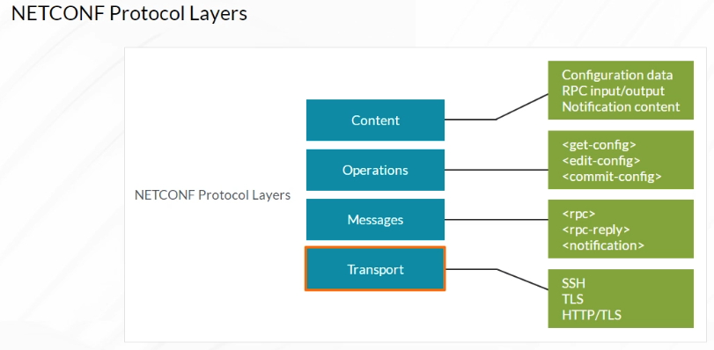

The Messages layer provides a simple, transport-independent framing mechanism for encoding remote procedure calls (RPCs) and notifications.

The Messages layer consists of three XML elements.

The <rpc> element encapsulates all RPCs sent to a NETCONF server. The <rpc-reply> element encapsulates all RPC replies from a NETCONF server including returned data and any OK, error, or warning messages. The <notification> element is a one-way message sent asynchronously to NETCONF clients that initiates a <create-subscription> RPC to the NETCONF server. When an event of interest occurs that meets the specified filtering criteria, an event notification message is generated. Refer to RFC 5277 for more details on notifications.

NETCONF messages are used in all NETCONF sessions to encapsulate NETCONF operational commands and data elements.

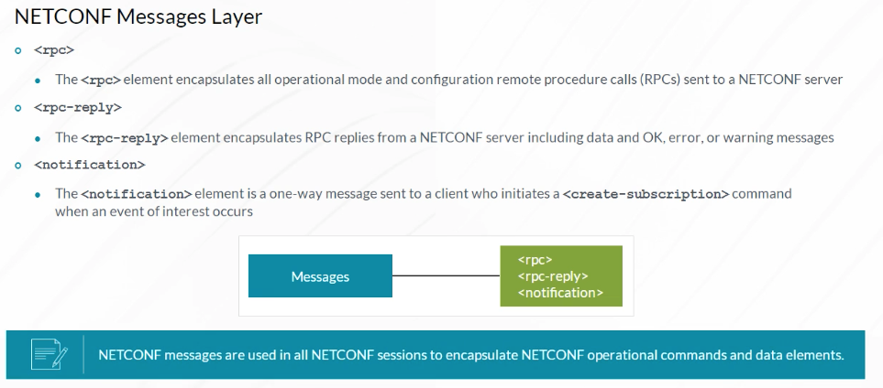

The Operations layer defines commands that are used to perform operations on a network device. These Operations layer commands are placed within one of the Messages layer tags explained earlier.

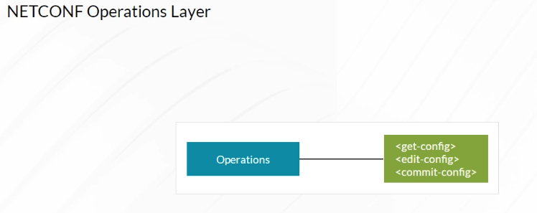

The different Operations layer commands are as follows:

•<lock>, which is used to obtain a lock on a device configuration file before modifying it,

•<unlock>, which is used to unlock a configuration after modifying it,

•<get>, which retrieves data from the running configuration database or device statistics,

•<get-config>, which retrieves the configuration from a device,

•<edit-config>, which is used to modify device configuration,

•<copy-config>, which creates or replaces an entire configuration,

•<commit>, which commits a candidate configuration,

•<discard-changes>, which rolls back a candidate configuration to the current running configuration,

•<delete-config>, which deletes a device configuration file,

•<validate>, which validates that the specified configuration can be loaded on the device,

•<create-subscription>, which creates a NETCONF subscription for notifications,

•<close-session>, which gracefully closes a NETCONF session, and

•<kill-session>, which closes a NETCONF session other than the one you are currently using.

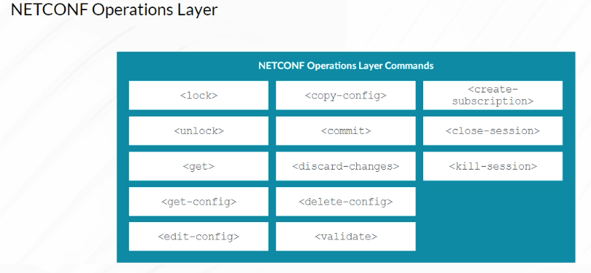

The NETCONF Content layer is where specific RPC parameters are encapsulated and sent to a NETCONF server. The XML API provided by the Junos mgd process on the server accepts and processes the incoming RPCs and generates an RPC response that is returned to the client.

The configuration data that you request from or upload to a Junos device is included in the Content layer. One good feature of NETCONF is that, other than the Transport layer that is normally encrypted using SSH, all other layers are clear text, making the protocol easy to monitor and troubleshoot.

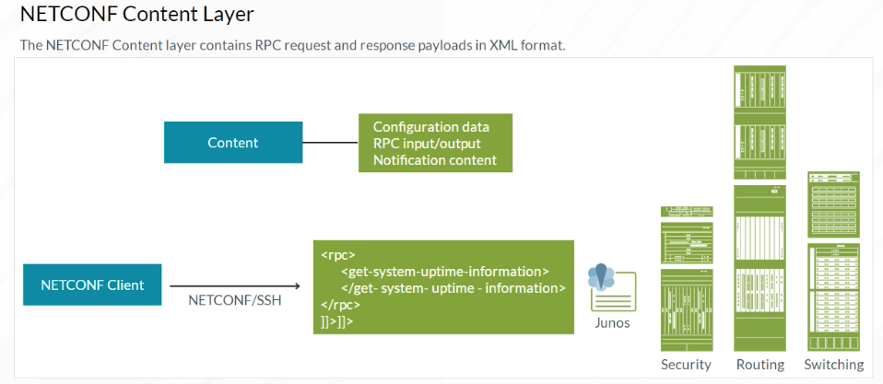

To enable NETCONF with SSH as the Transport layer protocol on a Junos device, issue the **set system services netconf ssh** configuration mode command. Junos defaults to using TCP port 830 for NETCONF over SSH connections. Some NETCONF client applications use the standard NETCONF TCP port 830 as specified in RFC 4742. To enable Junos OS to listen for NETCONF connections on port 830, issue the **set system services netconf ssh port 830** command.

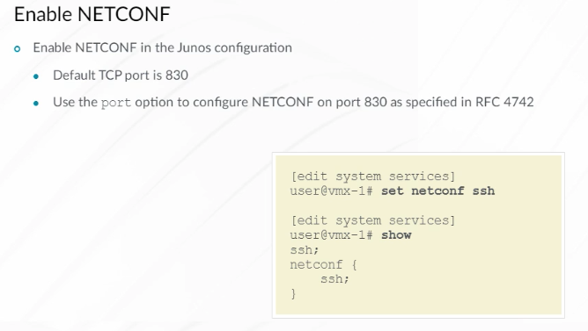

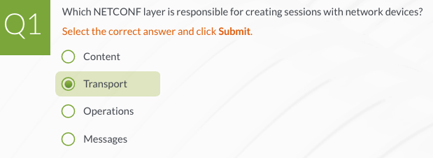

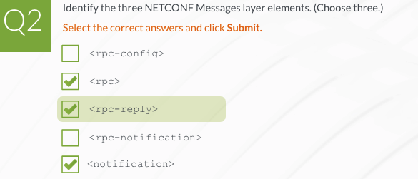

1. **XML and XPath**
2. **Python Fundamentals**
3. **Junos PyEZ operations**
4. **Junos PyEZ configuration**
5. **JSON and YAML**
6. **Junos REST API**
7. **Introduction to Junos**
8. **Introduction to Ansible**